Optimal Selection of Alternatives with Applications to Voting and Consumers' Choice

By John Lawrence April 2, 2016
copyright © 2016
Abstract

We devise a method for political and economic decision making that's applicable to choosing multiple alternatives from a larger set of possible alternatives. It is suitable for the selection of multiple members in a multi-member district. The method combines utilitarian voting with approval voting and sets an optimal threshold above which an individual voter's or chooser's sincere utility preference ratings are turned into approval style votes. We generalize utilitarian/approval hybrid voting which deals with a single member outcome to the case of multiple outcomes. The political case easily generalizes to the economic case in which a set of commodity bundles that will be made available by society is chosen from a larger possible set by the amalgamation of the individual choosers' inputs. As the set made available gets larger, the individual voter or chooser is more likely to gain greater utility or satisfaction.

Introduction

In Social Choice and Individual Values¹ Kenneth Arrow (1951) wrote, “In a capitalist democracy there are essentially two methods by which social choices can be made: voting, typically used to make ‘political’ decisions, and the market mechanism, typically used to make ‘economic’ decisions.” He goes on to say, “The methods of voting and the market … are methods of amalgamating the tastes of many individuals in the making of social choices.” Initially, Arrow does not distinguish between political and economic systems claiming that both are means of formulating social decisions based on individual inputs. Arrow then purports to show that there is no rational way to make social decisions based on the amalgamation of individual ones thus ruling out welfare economics, economic democracy and also direct political democracy. The dichotomy between political and economic systems remains with the implication being that representative democracy and capitalist economics are the best systems that can be devised.

Arrow's analysis is overstated in its basic assumptions. He assumes all individuals order entire social states consisting of “the amount of each type of commodity in the hands of each individual, the amount of labor to be supplied by each individual, the amount of each productive resource invested in each type of productive activity, and the amounts of various types of collective activity, such as municipal services, diplomacy and its continuation by other means, and the erection of statues to famous men.” This goes way beyond what is necessary for economic and political decision making. It is asking way too much of any individual voter or worker-consumer.

Arrow states “in the theory of elections, the alternatives are candidates.” He also states “In the theory of consumer's choice each alternative would be a commodity bundle...” However, Arrow assumes that only one candidate is elected from a single member district. (“On any given occasion, the chooser has available to him a subset S of all possible alternatives, and he is required to choose one out of this set.”) On the other hand, approval voting lets the voter choose more than one candidate, but society chooses only one to fill the elected position. In this paper we assume that multiple candidates can be elected from multi-member districts so that the voter can have a voice in choosing more than one candidate out of the set of available candidates, and there are multiple positions to be filled. Although members elected to a multi-member district are usually considered as equals, this method could produce rankings as well based on the final vote tallies.

Arrow has defined the alternatives in welfare economics as follows: “each alternative would be a distribution of commodities and labor requirements.” We consider the worker-consumer's initial role to be choosing which set of work-commodity bundles should be made available by society out of a larger possible set so that the selection process for both political and economic decision making is formally the same. Then a work-commodity bundle is assigned to or matched with each individual chooser from those available by means of a secondary algorithm or procedure which may or may not require further input from the individual choosers. This procedure, however, is beyond the scope and purview of this paper.

To state the problem formally, let S be the set of all political candidates (work-commodity bundles). Let W be the set chosen by society based on individual inputs.
W ⊂ S. |W| < |S|. We assume that voters (consumers) first determine their sincere utility preference ratings which are then converted using approval² voting (AV) methods. This conversion can be done by the individual or by the voting or choosing system itself. Society generates the set W based on the previously decided size of W. The top |W| vote getters would comprise that set which we call the “winning set.” We devise a rational method for determining which candidates (work-commodity bundles) should be given AV style votes by each individual voter (worker-consumer) based on their individual sincere preference ratings.

We continue with the understanding that, in order to simplify the discussion and unless otherwise stated, voters can be replaced with worker-consumers, candidates can be replaced with work-commodity bundles and vice versa.

Utilitarian and Approval Voting

As inputs Arrow insists on orderings instead of more nuanced cardinal input information or ratings in order to avoid interpersonal comparisons. However, voting, ergo facto, is a process in which all are assumed interpersonally comparable in terms of one person, one vote. We assume the same rationale for economic decision making. We take a utilitarian approach first developed by Harsanyi³ in 1955. Later Risse⁴ extended Harsanyi's Utilitarian Theorem.

The method considered here involves placing a threshold in an optimal manner such that all candidates with associated utilities above that threshold are given positive approval style votes. Candidates with associated utilities below threshold are given negative approval style votes. Utilities and preference ratings are assumed to be the same.

This manner of approval voting is considered sincere with respect to Niemi's⁵ definition of sincere approval voting. As Niemi points out, “... under AV sincere voters are still left with multiple strategies to consider.” Therefore, not all strategy is insincere.

Lehtinen⁶ asserts: “One reason why one individual has one vote under most rules is that each individual’s voting choice is considered equally important, and each individual’s utility is taken to carry at least roughly equal weight in the welfare function.” Regarding Arrow's condition, Independence of Irrelevant Alternatives (IIA), Lehtinen has shown that IIA is moot if strategy is involved which is the case in this paper. “However, from the utilitarian and thus welfarist point of view, strategic voting is desirable rather than undesirable under most commonly used voting rules.” Cox⁷ has also considered strategic voting in multi-member districts. We assert that the voting system considered here is both strategic and sincere.

The only relevant point to be made regarding IIA is that, if a candidate drops out from or is added to the set S, the threshold might change. Once the candidate set is finalized, the threshold will not vary due to the fact that candidate ratings using sincere cardinal information are assumed to remain constant for each voter regardless of candidate drop-outs or add-ons. For drop-outs or add-ons, the threshold would need an adjustment and would just have to be recomputed. The cardinal preference ratings of the voters regarding other candidates are assumed not to change.

Binmore⁸ also assumes that, even for a welfare economy or economic democracy, voting methods are used, and hence each individual chooser or voter is allocated the power of one vote thus equalizing all interpersonal comparisons.

Hillinger⁹ has also made the case for utilitarian voting:

“There is, however, another branch of collective choice theory, namely utilitarian collective choice, that, instead of fiddling with Arrow’s axioms, challenges the very framework within which those axioms are expressed. Arrow’s framework is ordinal in the sense that it assumes that only the information provided by individual orderings over the alternatives are relevant for the determination of a social ordering. Utilitarian collective choice assumes that individual preferences are given as cardinal numbers; social preference is defined as the sum of these numbers.”

Hillinger¹⁰ advocates Evaluative Voting (EV) in which the voter assigns a value to each candidate. For example, EV-3 assigns one of the values (–1,0,+1), and then the values are summed over all candidates to determine the winner. Lorinc Mucsi¹¹ also supports Hillinger in his advocacy for EV-3 which allows the voter to vote for, against or remain neutral regarding each candidate. The problem with approval voting, which Hillinger claims to ameliorate, is what to do with the candidates that are neither strongly approved of or strongly disapproved of ^{i.e.} those in the middle. Hillinger assigns these candidates a value of zero. He¹² asserts:

“Another criticism of AV, is due to Lawrence Ford, chair of the mathematics department, Idaho State University, ... :

One big flaw [of AV] is that most voters are fairly positive of their favorites and fairly positive of those they hate, but wishy-washy in the middle. If they choose randomly for or against approval in that middle range, the whole election can become random.

Directed against AV, this criticism has some validity because under AV, not to approve a candidate is equivalent to being against him. This puts the voter in a bind of having to be for or against, when in fact he lacks the relevant information for [such] a judgment.”

The use of an optimal threshold to determine which candidates get an approval style vote of +1 and which get an approval style vote of –1 clears up one of the criticisms of approval voting regarding what to do about candidates that a voter is wishy washy about. All those above threshold get a +1 vote; all those below get a –1 vote. The only ones who would get a 0 vote would be those that fell directly on or close to the threshold.

Lehtinen concludes that Arrow's Impossibility Theorem is not relevant in the final analysis: “Arrow’s impossibility result and the closely related theorems given by Gibbard¹³ and Satterthwaite¹⁴ are unassailable as deductive proofs. However, we should not be concerned about these results because their most crucial conditions are not justifiable. Fortunately, we know that strategy-proofness is usually violated under all voting rules and that IIA does not preclude strategic voting.” Gendin¹⁵ also considers Arrow's Impossibility Theorem to be “invalid.”

The theory advanced herein results in approval voting in the sense that individual cardinal inputs are converted to approval style votes. Historically, approval voting is still geared to selecting one candidate from a single member district. In that case it has been shown that votes should be cast for all candidates who are above average with respect to a voter's cardinal rating scale. Smith¹⁶ has proven the following: “Mean-based thresholding is optimal range-voting strategy in the limit of a large number of other voters, each random independent full-range.” Range/approval hybrid voting is similar to utilitarian voting followed by approval voting. Lehtinen¹⁷ has used expected utility maximising voting behavior to indicate which candidates should be given an approval style vote in single member districts. He agrees with Smith that an approval style vote of +1 should be given to all candidates for whom their utility exceeds the average for all candidates. All others would get an AV vote of zero. For single member districts then the optimal threshold is placed at the mean of the sincere ratings for each individual.

An undesirable aspect of most voting systems is Bayesian regret. Bayesian regret is the difference in overall social utility between a voting system that maximizes social utility and the voting system under consideration. Smith¹⁸ has measured Bayesian regret for several different voting systems via computer modeling. He has shown¹⁹ that range (or the renamed score) voting is the best system with regards to Bayesian regret for single member districts.

The method presented here combines utilitarian voting followed by EV-3 style approval voting based on an optimal threshold. With regard to Bayesian regret, the stance taken here is that it is the price to be paid for a voting system which is stable in the sense that everyone gets the benefit of an optimal strategy which can be computed by the individual voter or can be provided by the system itself in such a way that no one can gain an advantage by misrepresenting their sincere preference ratings. If done in this way, it negates the advantage of strategizing by individuals and equalizes the benefits of strategizing for all voters. By doing so two things are accomplished: 1) there is nothing to be gained by an individual voter in strategically misrepresenting their sincere preferences so that each voter has an incentive to vote sincerely, utilitarian style, using their true preference ratings, and 2) each voter will be assured that they will gain the advantages of an optimal strategy.

Calculating the Optimal Threshold

Strategic considerations lead to applying a formula to each individual's sincere preference ratings in order to maximize the outcome for that individual. For the purposes of this paper and without loss of generality, individual utility preference ratings are determined on a real number scale from –1 to +1. A threshold is set above which the sincere preference ratings are converted to +1 AV style votes. Every rating below threshold is converted to – 1. Preference ratings falling right on or close to the threshold can be given a 0 vote similar to Hillinger's¹⁰ preferred EV-3 voting method.

Finally, the approval style votes for each candidate are summed over all voters, and the candidate(s) with the most votes are declared the winner(s).

We will only consider the case in which individual strategy occurs without knowledge of statistical or polling information regarding other voters. Lehtinen¹⁶ considers a case in which the statistics regarding other voters are taken into account.

For single member districts our assumptions are similar to those of Smith and Lehtinen except for the fact that we have changed the preference rating scale, without loss of generality, from (0,1) to (–1,0,+1). In this case we show that the threshold should be placed near the mean of the utility preference ratings which agrees with their analysis.

For multi-member districts, the threshold needs to be adjusted upwards from the mean utility as will be shown. We use the concept of expected utility maximising to make a decision as to where to place the threshold above which all candidates will get an approval style vote of +1. Brams and Fishburn state²⁰: “Because approval of a less-preferred candidate can hurt a more-preferred candidate, the voter still faces the decision under AV of where to draw the line between acceptable and nonacceptable candidates.” This paper resolves that dilemma. The threshold will vary depending on the number of members to be chosen, and it will vary for each individual voter.

In a multi-member district, the voting procedure will select a number of candidates, the set, W, from a larger set of candidates, S. In the economic case, the choosing procedure can be thought of as deciding which work-commodity bundles should be made available (the set W) from a larger set of possible bundles (the set S).

Let m = |W| < |S| represent the size of the winning set of candidates. In a single member district, for example, m = 1. When m > 1, as in a multi-member district, it is assumed that each voter would seek to maximize the utility for them of the set, W. The utility of the winning set for the individual voter can be computed from that individual's sincere preference ratings. The social utility would be the summation over all voters of their utilities for the winning set. Bayesian regret would be the difference between this and the maximum social utility computed over all possible winning sets.

In the economic case the social utility can be computed by summing over the utilities of the work-commodity bundles that are matched with the individual choosers. If the winning set, W, is large compared to the total number of possible outcomes, |S|, the worker-consumer is likely to get an outcome that is closer to their first choice with respect to their sincere preference ratings.

Let’s examine an individual citizen’s preference ratings which represent a specification of utilities over the candidates with each utility corresponding to a position on the preference rating scale which we choose, without loss of generality, to be a real number between –1 and +1. Each individual voter associates each candidate with a particular utility on that scale. For sincere utilitarian voting, the greater the indicated utility, the greater the probability that a particular candidate will be elected due to that individual voter's rating alone since utilities for a particular candidate are additive over all voters.

The greater the utility for a particular candidate, the more likely it is also that that candidate will get an approval style +1 vote in the case of AV or EV-3¹⁰ voting. For each value of m, we place the threshold such that the expected utility for the set of candidates with preference ratings greater than threshold is a maximum.

Let C be the set of all candidates, c_{i} be a particular candidate with associated utility, u_{i}, U be the set of utilities corresponding to all candidates, U_{a} be the set of utilities above threshold and U_{b} be the set of utilities below threshold. Let C_{a} be the set of candidates above threshold and C_{b} be the set of candidates below threshold. Let u_{a} be the sum of utilities above threshold and u_{b} be the sum of utilities below threshold. Let the number of candidates above threshold be n_{a}. Let n_{b} be the number of candidates below threshold so that n = n_{a} + n_{b} = total number of candidates with associated utilities.

We must distinguish between the utilities of the particular individual's preference rating scale before voting and his or her expected utilities for the set W which is determined by the voting process. Let V be a random variable which represents the utility of the winning set if all candidates were given an approval style +1 vote.

where p_{r} represents the utility of the r^{th} candidate with associated utility u_{r} being in the winning set. This can also be written as

where the first term is the expected value of utility for the set of candidates above threshold and the second term is the expected value of utility for the set of candidates below threshold.

We seek to maximize the expected value of utility for the set of candidates above threshold:

where Va is a random variable representing the utility of the set of candidates above threshold.

Since we assume no knowledge of statistics regarding the outcome of the election process, other voters' preferences or polling data, the probability of any particular above threshold candidate being in the winning set is the same for all candidates above threshold.

The expression for p_{i} is the following:

This can be interpreted as the probability that an above threshold candidate, c_{i}, is in the winning set given that one or more above threshold candidates are in the winning set times the probability that one or more above threshold candidates are in the winning set.

The probability of the i^{th} candidate being in the winning set given that one or more above threshold candidates are in the winning set is 1/n_{a} . The probability of one or more above threshold candidates being in the winning set can be expressed by the hypergeometric function which is a discrete probability distribution. It can be modeled as a ball and urn problem containing white and black balls. The candidates above threshold are identified with white balls and the candidates below threshold are identified with black balls. We posit a “picker” that picks balls randomly one at a time out of the urn without replacement and places the balls in the winning set.

The mathematics for this is the following:
where p' equals the probablity of k above threshold candidates out of m picks, without replacement, from a finite population of size n containing exactly n_{a} white balls, wherein each draw can either produce a white ball (an above threshold candidate) or a black ball (a below threshold candidate).

We let p be the probability that at least one above threshold candidate is selected.

p = 1 – p' (every candidate selected is below threshold)

In general we have

for m < n – n_{a} –1

The expected value of utility associated with above threshold candidates for a particular individual voter is the following:

Therefore,
We want to determine where to place the threshold so as to maximize the expected utility of those candidates above threshold for the individual voter under consideration. To simplify the discussion, let us assume, as an example, that the values of the possible utilities are uniformly spread from –1 to +1 in accordance with the spacing,

and that there is one candidate corresponding to each utility. The results are easily extended to a more generalized solution since they only depend on the sum of utilities above threshold, the number of candidates above threshold, the total number of candidates and the size of the winning set.

We do the computations for every possible threshold to determine which threshold is best ^{i.e.} which threshold results in the maximum value of expected utility of the winning set for the individual voter under consideration. An algorithm, which would find the maximum more efficiently, could be used, but that is beyond the purview of this paper. All candidates above threshold will have their votes increased to +1, and those below threshold will have their votes decreased to –1. Candidates whose utilities fall exactly on or close to the threshold will be set to zero. The results for all candidates will then be tallied over all voters. Maximizing individual voter satisfaction or utility has to do with the correct placement of the threshold for each individual.

Let's do an example with m = 1 which should check with the previous result from Smith¹⁶ and Lehtinen¹⁷ for utilitarian/approval hybrid voting.
Expected value of utility =
If we place the threshold just under –1, n_{a} = n, p = 1, u_{a} = 0, E(V_{a}) = 0.

If we place the threshold just under +1,

n_{a} = 1, u_{a} = 1, p = 1/9 and E(V_{a})=1/9.

When the threshold is just over +1, n_{a} = 0, u_{a} = 0, p = 0. We define the value of E(V_{a}) to be 0 at a utility of 1+ (2/n-1). In general, for n large, E(V_{a}) can be made to be zero for a value of utility equal to 1 + ∆ with ∆ being arbitrarily small.

Let's do an example for the following data set:

u_{i} ∈ {-1,-3/4,-1/2,-1/4,0,1/4,1/2,3/4,1)

Expected utility is a maximum when the threshold is close to u_{i} = 0 , n_{a} = (n–1)/2. This agrees with the former analysis by Smith¹⁶ and Lehtinen¹⁷ since the threshold is placed at the mean. The maximum value of expected utility can be made to occur arbitrarily close to a threshold of zero by increasing n. The graph is as follows:

Let us consider the case of a winning set of just 2 members, m = 2. We should be able to raise the threshold from near the average of the individual's ratings since the voter is more likely to get an outcome closer to their most preferred outcome. We proceed to find the optimal placement of the threshold.

According to the formula,

For the set u_{i} ∈ {-1,-3/4,-1/2,-1/4,0,1/4,1/2,3/4,1), we have

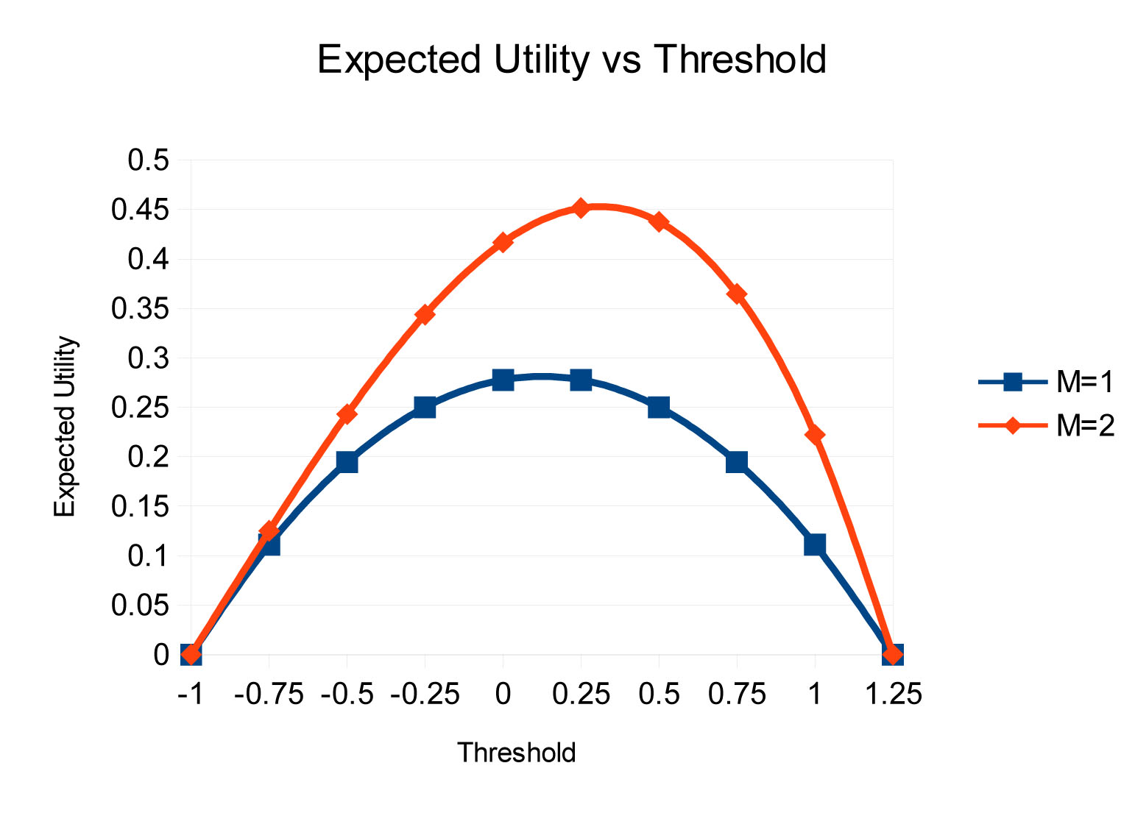
Here are the graphs for m=1 and 2:

We can see that the peak has shifted to the right and upwards indicating that the threshold for which expected utility is maximum has shifted up towards greater utilities and the expected utility at that threshold is greater.

As m increases, the individual under consideration should derive increased utility or satisfaction from the winning set since one or more of their above threshold candidates are more likely to become part of the winning set W.

Now we increase the data set as follows

u_{i} ∈ {-1, -.95, -.9, …, -.05, 0, .05, …, .9, .95, +1}

The graph is the following:

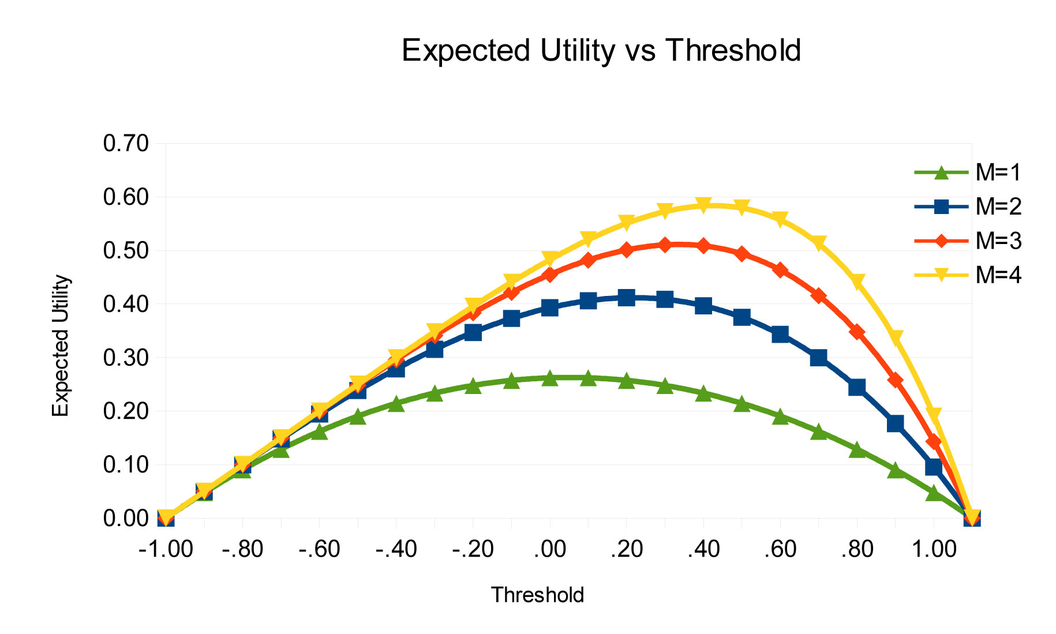
For higher values of m, please see Appendix 2.

The problem easily generalizes to the case in which the utilities associated with the candidates are not uniformly distributed over the range of utilities since only the average value of the sum of utilities above threshold is used in the calculations. The value of probability used in the calculations depends on the number of candidates above threshold divided by the total number of candidates and the size of the winning set, m.

Summary and Conclusions

We have demonstrated a method for choosing candidates in a multi-member election or for choosing a set of worker-consumer bundles from a larger possible set of bundles. The method generalizes from the political case to the economic case. In each case a winning set, W, is chosen from a larger set, S. W ⊂ S. |W| < |S|.

The only difference is that in the political case the voter is represented by all members of the winning set. In the economic case, a work-commodity bundle is assigned to or matched with each individual chooser from those available by means of a secondary algorithm. In both cases the voter/worker-consumer chooses their ballot in such a way as to maximize the utility to them of the winning set or it is done for them by the system itself after the submission of sincere utility preference ratings. If done the latter way, any gains from strategizing are distributed equally throughout the electorate. This makes it impossible for an individual to gain anything by voting insincerely.

No knowledge of the statistics of the voting or choosing procedure are assumed.

A threshold is placed so as to maximize the expected value of utility for the set of candidates above threshold for each individual. Those candidates above threshold are given an approval or EV-3 style vote of +1, and those candidates below threshold are given an approval or EV-3 style vote of –1. Candidates falling on or near the threshold are given an EV-3 style vote of 0.

After the approval style votes are tallied over all individuals, the candidates with the
m = |W| highest totals are chosen to be in the winning set. The method for determining the threshold has been graphically illustrated for a uniform distribution of candidates with real number associated utilities from –1 to +1. The method is easily generalized for any distribution of candidates and utilities.

Thresholds can be determined in advance by sophisticated computer algorithms. The computations in and of themselves should not be a hindrance to the implementation of this system.

Smith¹⁶ and Lehtinen¹⁷ have proven that, for the case of one possible realized outcome, the best choice of threshold for each individual is the arithmetic mean utility of the sincere utility preference ratings over all the candidates. Therefore, utilitarian/approval voting has been proven to be optimal for this case. This paper generalizes that result for m > 1. We show how to compute the position of the optimal threshold. Then the sincere preference ratings can be converted to approval style, EV-3 votes.

We have shown that both political and economic utility or satisfaction increase as the size of the winning set, m, increases. We show in Appendix 1 that for a uniform distribution of candidates with corresponding utilities and a given threshold index, t, (0 ≤ t ≤ n-1), the expected value of above threshold utilities, E(V_{a}), can be maximized by increasing m and the maximum value of E(V_{a}) is equal to t/ (n-1) at that threshold.

We show in Appendix 2 a graph depicting expected utility vs threshold for values of m ranging from 1 to 16.

This theory represents a meta-theory from which both political and economic solutions can be derived and unifies the split in social choice theory between political and economic decision making.

Arrow's Impossibility Theorem gave a theoretically endorsed superiority to winner-take-all, majority rule, single member districts. By the same token there was a tacit endorsement of the capitalist economic system since, according to the Theorem, there is no rational method of choosing economic outcomes based on individual inputs. This paper challenges those assumptions and asserts that there is a rational method for aggregating individual choices into rational social decisions.

Appendix

Appendix 1:

Theorem 1: For a uniform distribution of candidates with associated utilities and a given threshold index, t, (0 ≤ t ≤ n-1), E(V_{a}) can be maximized by increasing m and the maximum value of E(V_{a}) is equal to t/(n-1) at that threshold.

As the threshold increases from 0, for a given m, u_{a} increases.

t = n – n_{at}

n_{at} = n_{a} at threshold index t

–1 ≤ u_{a} ≤ 1

Let u_{at} represent ua at threshold t,
u_{at} ∈ {u_{a0}, u_{a1}, u_{a2}, …, u_{an}}

u_{a0} = u_{an} = 0 by definition.

Therefore,

t < n, m < n

The second term in p_{at} can be driven to zero by increasing m.
If m is sufficiently great, t → (n-1), p_{at} → 1,

and

Appendix 2: Graph for Higher Values of m

References

- Arrow, Kenneth J. (1951), Social Choice and Individual Values, Yale University Press, p. 1.
- Brams, Steven J. and Fishburn, Peter C. (1983), Approval Voting,
Birkhauser-Boston.
- Harsanyi, John C. (1955), “Cardinal Welfare, Individualistic Ethics, and Interpersonal Comparisons of Utility”, The Journal of Political Economy, Vol. 63, Issue 4, pp. 309-321.
- Risse, M. (2002), “Harsanyi's 'Utilitarian Theorem and Utilitarianism,” Nous, Vol. 36, No. 4, pp. 550-577.
- Niemi, Richard G. (1984) “The Problem of Strategic Behavior under Approval Voting,” The American Political Science Review, Vol. 78, No. 4, pp. 952-958.
- Lehtinen, Aki (2011), “A Welfarist Critique of Social Choice Theory,” Journal of Theoretical Politics, Vol. 23, No. 3, pp. 359-381.
- Cox, Gary W. (1984), “Strategic Electoral Choice in Multi-Member Districts: Approval Voting in Practice?*”, American Journal of Political Science, Vol. 28, No. 4, pp. 732-738.
- Binmore, K. (2009), “Interpersonal Comparison of Utility,” The Oxford Handbook of Philosophy of Economics.
- Hillinger, C. (2005), “The Case for Utilitarian Voting,” Homo Oeconomicus, Vol.22, No. 3.
- Hillinger, C. (2004), “Utilitarian Collective Choice and Voting,” Online at http://epub.ub.uni-muenchen.de/473/
- Mucsi, Lorinc (2015), “A Discussion on the Merits of Evaluative Voting,” Western Undergraduate Economics Review, pp. 21-34.
- Hillinger, Claude (2004), “Voting and the Cardinal Aggregation of Judgements,” University of Munich: Department of Economics 9, pp. 1-25. http://epub.ub.uni-muenchen.de/353/1/hillinger_voting.pdf
- Gibbard, A. (1973), “Manipulation of voting schemes: a general result,” Econometrica, Vol. 41, No. 4, pp. 587–601.
- Satterthwaite, M. A. (1975), “Strategy-proofness and Arrow's Conditions: Existence and Correspondence Theorems for Voting Procedures and Social Welfare Functions,” Journal of Economic Theory, 10, pp. 187–217.
- Gendin, Sidney. (1994), “Why Arrow's Impossibility Theorem Is Invalid,” Journal of Social Philosophy, Vol. 25 No. 1, pp. 144-159.
- Smith, Warren, http://www.rangevoting.org/RVstrat3.html#conc
- Lehtinen, Aki (2007), “The Welfare Consequences of Strategic Behaviour Under Approval and Plurality Voting,” European Journal of Political Economy, Vol. 24, No. 3, pp. 688-704.
- Smith, Warren, http://rangevoting.org/BayRegDum.html
- Smith, Warren, http://rangevoting.org/StratHonMix.html
- Brams, S.J. and Fishburn, P.C. (2005) “Going from theory to practice: the mixed
success of approval voting,” Social Choice and Welfare, Vol. 25 pp. 457–474.

